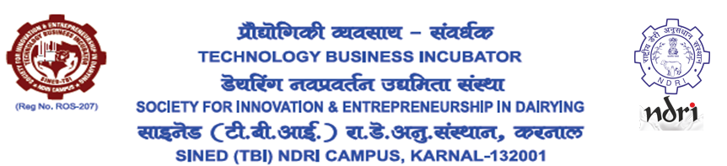

**Application is invited in prescribed proforma for the following post of SINED-TBI of ICAR-NDRI, Karnal**

**Chief Executive Officer (CEO)**

**Essential Qualification:** Master of Business Administration (MBA) from a reputed Recognized Business School / University with Bachelor’s degree from a recognized institute/University in Dairy/Food/Agriculture/Animal Science/any of the Science subjects.

Or

Post Graduate Diploma in Management (Agri Business Management) from a reputed Recognized Business School / University with Bachelor’s degree from a recognized institute/University in Dairy/Food/Agriculture/Animal Science/any of the Science subjects.

**Desirable Qualification:** Working experience in running an enterprise preferably a TBI/STEP/BPD/ABI/ Technology Commercialization/ project appraisal/Start up evaluation with good communication skills and proven leadership qualities.

**Job description:** Responsibilities include taking lead in organizing various activities, liaison with the potential incubatees/Dairy and Food Industries/Financial Institutions and work out a feasible work plan as per the requirements of NDRI & TBI, organization of training programmes vis-à-vis mandated activities, overall Financial/resource management for the TBI etc.

**Salary:** Rs 75,000/- per month consolidated.

**Age limit:** Maximum 62 years

**Note**:

1. The post is purely on contractual basis for one year from the date of joining with a scope for further extension based on the performance - *mostly* in terms of number of incubatees joined, revenue earned to make the TBI financially self-sustaining, etc.
2. Incentives and salary hike would be based on the annual performance and the decision of the Board of Governors.
3. No correspondence/ representation will be acceptable on termination after or before one year.
4. The President, SINED-TBI has full power to terminate his/her services without giving any reason.

Apply with detailed resume (hard & soft copy) in the given Application Form (Page 3-5) by 05/02/2024 to: Secretary, SINED-TBI, ICAR-NDRI. email: [stbindri@gmail.com](mailto:stbindri@gmail.com) The subject of the email should be: Application for the Post of MD-SINED-TBI - Applicant Name. A hardcopy of the application should also be sent by speed-post to: Secretary, SINED-TBI, ICAR-NDRI Campus (Behind Dairy Technology Division), Karnal – 132 001, Haryana.

**APPLICATION FORM**

|  |
| --- |
| **Affix Photograph Here** |

|  |  |  |
| --- | --- | --- |
| Sr. No. | Particulars |  |
| 1 | Full Name  (in Capital Letters) |  |
| 2 | Fathers/ mothers name |  |
| 3 | Address (Present) |  |
| 4 | Address (Permanent) |  |
| 5 | Contact No. |  |
| 6 | Email. |  |
| 7 | Id Proof.  No. |  |
| 8 | Date of Birth and age on 31/01/2024 in years and months |  |

9. Educational qualification:

|  |  |  |  |  |  |
| --- | --- | --- | --- | --- | --- |
| Sr. No. | Name of the School/Institute/University | Name of the degree | Percentage of marks | Year of passing | Position held (if any) |
|  |  |  |  |  |  |
|  |  |  |  |  |  |
|  |  |  |  |  |  |
|  |  |  |  |  |  |

**10. EXPERIENCE DETAILS:**

|  |  |  |  |  |  |
| --- | --- | --- | --- | --- | --- |
| Sr. No. | Name of the organization &  Address | Job description | Position held | Period from | Period  to |
|  |  |  |  |  |  |
|  |  |  |  |  |  |
|  |  |  |  |  |  |
|  |  |  |  |  |  |

**11. Relevant Trainings/ Certificates:**

|  |  |  |  |  |
| --- | --- | --- | --- | --- |
| Sr. No | Title of Training/ certificate | Training Institution | Period  from | Period  to |
|  |  |  |  |  |
|  |  |  |  |  |
|  |  |  |  |  |
|  |  |  |  |  |

12. Any other information you may like to provide in support of your candidature (describe within 200 words)

I hereby declare that all the information furnished above are true to the best of my knowledge and belief.

(Signature)

***(Enclose photocopies of documents in support of above.)***