**Skill development on scientific/precision dairy farming for women empowerment of Bolpur, Birbhum district of West Bengal under SCSP and TSP program**

ICAR-National Dairy Research Institute-Eastern Regional station, Kalyani organized a 3-days training programme on scientific/ precision dairy farming for women of Bolpur, Birbhum district of West Bengal at NDRI, Kalyani campus during 25th – 27th July, 2023 under SCSP and TSP program of the Institute. A total of 40 women farmers participated in this training programme. In this inaugural session of training programme, Dr. S. M. Deb., Principal Scientist & Head, Dr. Ajoy Mandal, Principal Scientist & Nodal Officer, SCSP, Dr. T. K. Dutta, Principal Scientist & Nodal Officer, TSP and all scientists and technical officers were present. At the outset of this programme, Dr. S. M. Deb., Principal Scientist & Head, welcomed all the participants and briefed about the schemes and highlighted about the importance of this training program to the participants. Under this training programme, lectures on suitable cattle and goat breeds and their selection, nutritional management, their reproductive management, housing management, Artificial Insemination, common diseases of cattle and goats and their control and prevention etc. were delivered by expert/scientists of this Institute. The women farmers’ were also informed about the scope of dairy farming at this region and how to set up dairy farm with exploring the Govt./private schemes for establishing such set up and developing entrepreneurship at village level. The importance of scientific as well as precision farming in dairy was also discussed at length and live demo on precision cattle farming was shown to the participants. During the valedictory programme, Dr. Asif Mohammad, Senior Scientist and Incharge, Extension section, sought the opinion of participants about this programme. All the participating farmers expressed their keenness as well as happiness in participating in this programme. Dr. S. Banik, Head, ICAR-NDRI, ERS, Kalyani, in his valedictory speech, expressed his satisfaction on the feedback of the participants and informed the participants that this Institute will definitely organize such trainings in future to empowered the capacity building of women farmers’ in other villages of Birbhum and Nadia districts of West Bengal. During this program, the certificates were also distributed to all the participants after successful completion of the training.

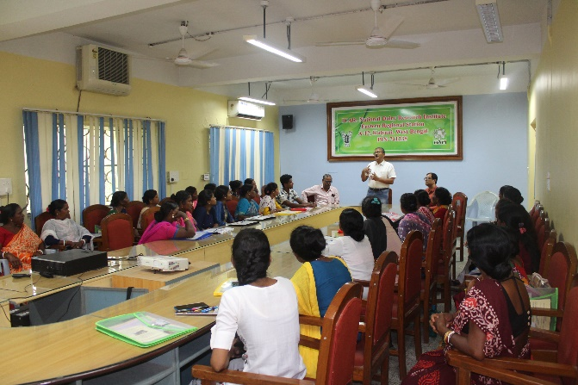 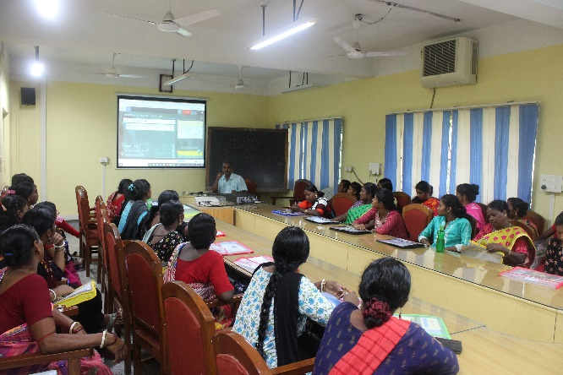 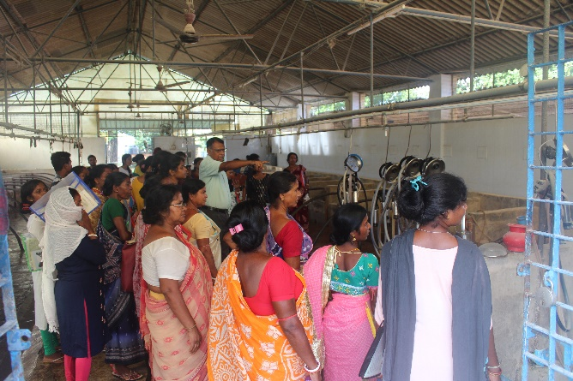 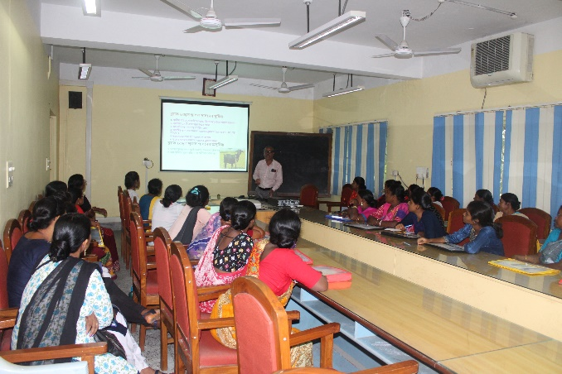 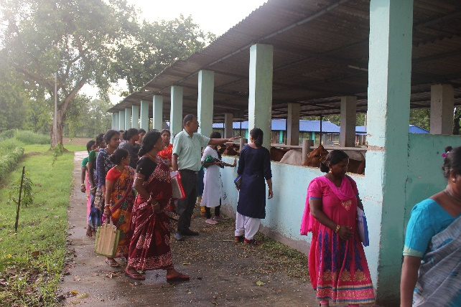 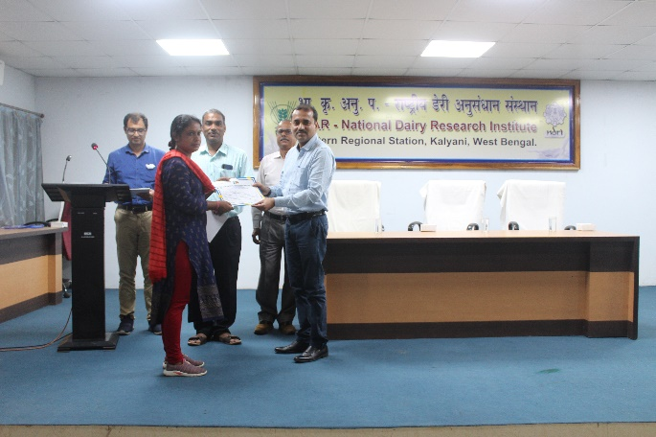

Glipmses of training programme